**CSE3506 Essentials of Data Analytics**

Name : **Sparsh Raj**

Reg. No. : **19BPS1028**

Lab Exercise: 8: K-medoids

**Objective:** To perform K medoid clustering on the given data.

**Question:**

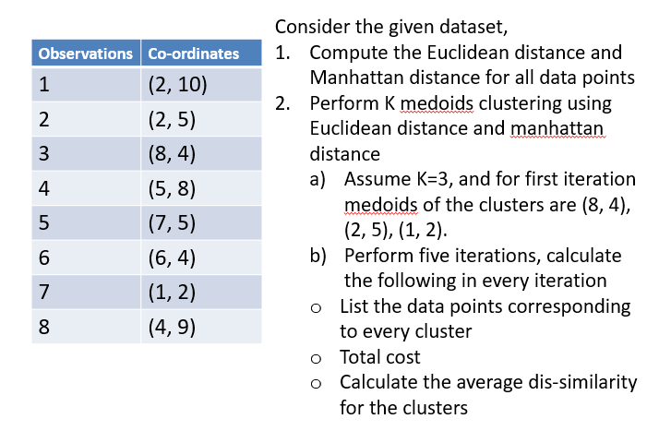

**Methods:**

1. Divide x and the y values into two separate columns.
2. Use the given centers to calculate the distance of all the points from all the three centers.
3. Using the values of the distance calculated, categories the given points into different groups.
4. In each separate group, calculate the value of median for both x and y coordinate
5. Use these medians to calculate the distances and repeat all the steps once again for the next iteration.
6. Stop after 3 iterations.

**Iteration 1:**

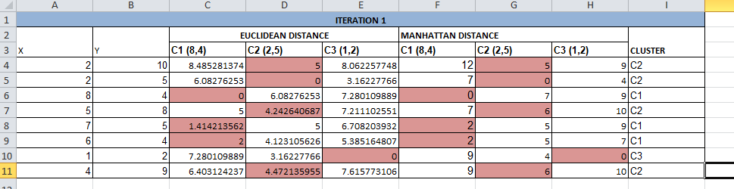

**Iteration2:**

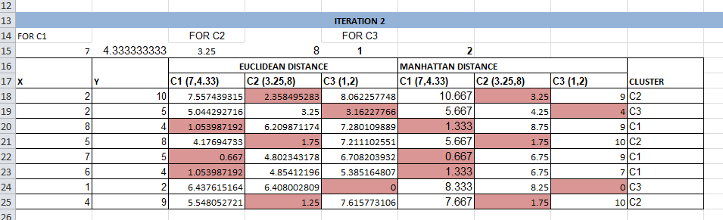

**Iteration 3:**

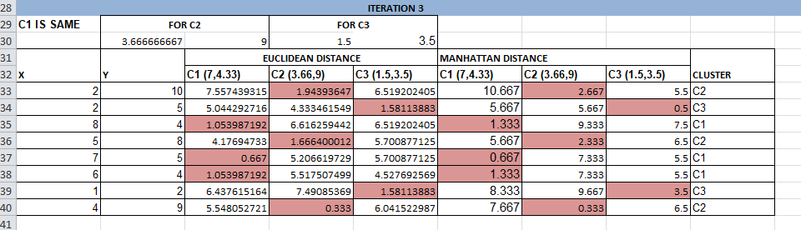

The ML model matured after the second iteration and gave similar results in 3rd iteration. There was only one point in the third cluster while the other clusters were perfectly classified.

**Conclusion**

In this experiment we were successfully able to perform K-Medoid clustering using spreadsheets. The results produced were very accurate and reliable. In addition we were able to gather key insights of the given data.